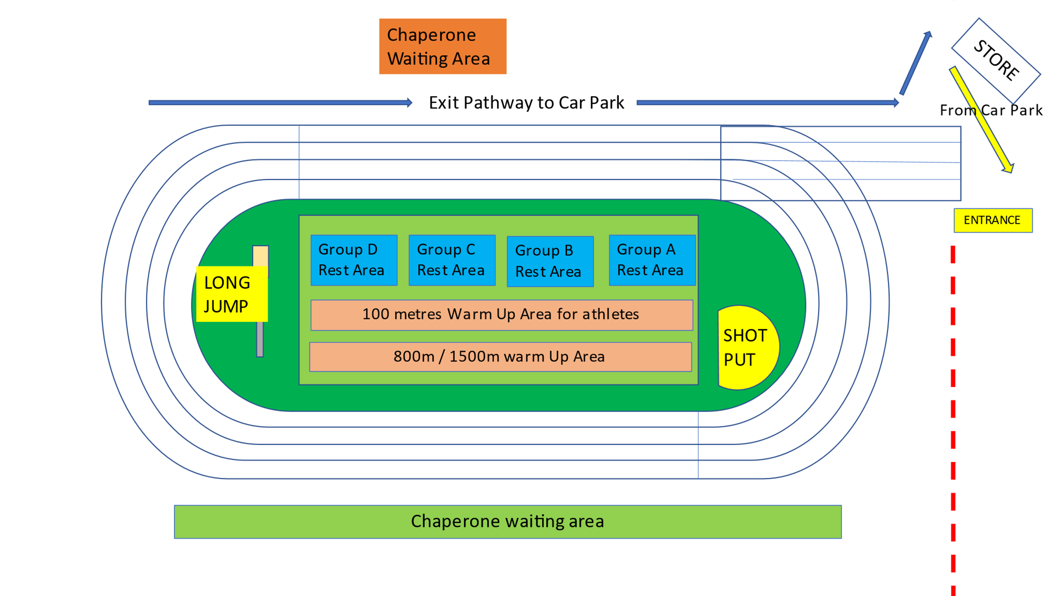

One-way system around track

Entry

Exit

Registration

Table

Access from Main Uni Car Park

Athlete Waiting Area

Warm-Up Area

Toilet’s exit

Toilet’s entrance

Craig Gowans Building

**🡨 Access to main university entrance and car park via A9**

**(Please do not use access road marked in red, no parking available outside Sport Scotland building)**